NEWS | From the Office of  Patricia Pike  Missouri State Representative  District 126
FOR IMMEDIATE RELEASE:  February 18, 2019 |  | CONTACT: Patricia Pike  573-751-5388
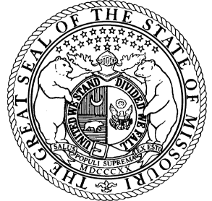

Women Legislators of Missouri Scholarship

JEFFERSON CITY, Mo. – Women Legislators of Missouri, are encouraging young women, set to graduate from high school, to apply for a $500 college scholarship. Each year the group selects one student from each of Missouri’s congressional districts to receive the award. Members hope to spread the word about the scholarship opportunity so that female students from all parts of the state will apply.

“This is a great opportunity for any young woman,who are interested in continuing her educational studies, to receive valuable financial assistance,” Said Representative Patricia Pike, chair of the group.

The Women Legislators of Missouri Caucus is made up of Missouri Legislators serving in the House and Senate. They created the senior scholarship program to provide financial assistance to students on the basis of leadership, academics and community service. Candidates must fill out an application and are required to submit a 500-word essay answering the question, “If you were a state legislator, what would you hope to accomplish and why?”

The electronic link to download the scholarship is located at https://myscholarshipcentral.org.

The submission deadline is March 15th, 2019

The group will select recipients and then hold a reception in their honor at the State Capitol House Monday, April 15th, 2019. Scholarships will be presented to the recipients in the Missouri House Chamber. For further information, contact 573-751-5388 or email Patricia.Pike@house.mo.gov.

-###-

